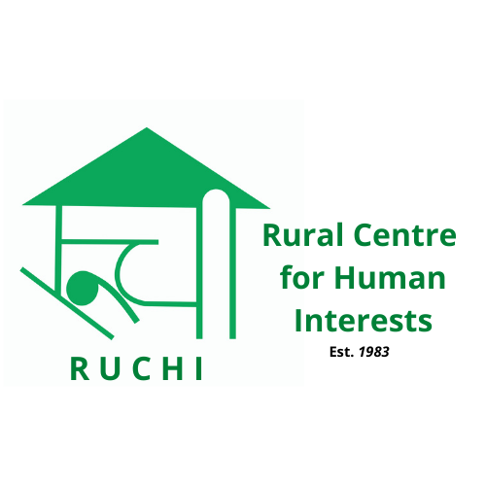

RUCHI
Rural Centre for Human Interests

Volunteer India program
STV Spring Projects (2026)

Correspondence:
RUCHI
Technology Complex
Village Bandh, P.O. Bhaguri, Via Patta
Distt. Solan. H.P. - 173233
INDIA

Contact info:
Landline: +91-7560078500 (9Am to 5PM)
Mobile: +91-9459377111 (Mahip Dagar)
Email: info@ruchi.org.in
Website: www.ruchi.org.in

RUCHI Short Term Spring Work Camps - 2026
(Code: RC)
Code | Project / Theme | Location | Theme | Dates  2026 | Max.  Places
RC-01/26 | Explore the unexplored | Solan Bandh | CUL | 09/02 – 18/02 | 10
RC-02/26 | Peace & Resillience | RUCHI | SOC | 23/02 – 05/03 | 10
RC-03/26 | Holi – Festival of Colors | Solan-RUCHI | FEST/CUL | 02/03 - 11/03 | 10
RC-04/26 | Tibetan Culture & Social Development | Dharamshala & Solan | SOC/CUL | 16/03 - 25/03 | 10

General Information:
- All Short Term Camps (STC) last upto two weeks with fixed dates and led by a RUCHI Team Leader.
- Every project has an extra fee to cover their living and working costs. Volunteers take care of their own travel costs and bear all personal expenses during free time and leisure visits.
- Volunteers have to be 18 years or older and be prepared to live under simple conditions.
- No special skills are required; one has to be open minded and willing to adapt to challenging conditions.
- Volunteers’ contribution is always recognized and appreciated but they will have to accept the fact that they cannot change the world in two weeks.
- Volunteers must be willing to understand and respect local as well each other’s culture.
- Volunteers must be prepared to live in harmony with others and work as a team.
- Working hours will be 5-6 hours, 5 days a week.

Why the extra fee?
RUCHI with other NGO’s in India is not financially supported by government to host projects related to IVS. Hence all projects are self funded with a participation fee. Given the remote location and various complexities we have tried our best to make it as affordable as possible for volunteers. Being a non-profit organization we emphasize on transparency, below is how we spend collected participation fee.
- Food, accommodation and logistics of volunteer during workcamp.
- Project setup costs. (material and logistics cost)
- Running the camp. (wages of professional skilled mason, carpenter, plumber etc and training local youth supported by us.)
- Office running/admin expenses. (Internet, photocopy, stationary, electricity, phone, salaries, office equipment, tools and rent etc.)
- Supporting small community project.
- International travel costs to global conferences and network membership fees.

Description of the Short Term Camps

RC-01/26 Explore the unexplored Solan SOC/CUL 10 Vols. 09.02.26 – 18.02.26

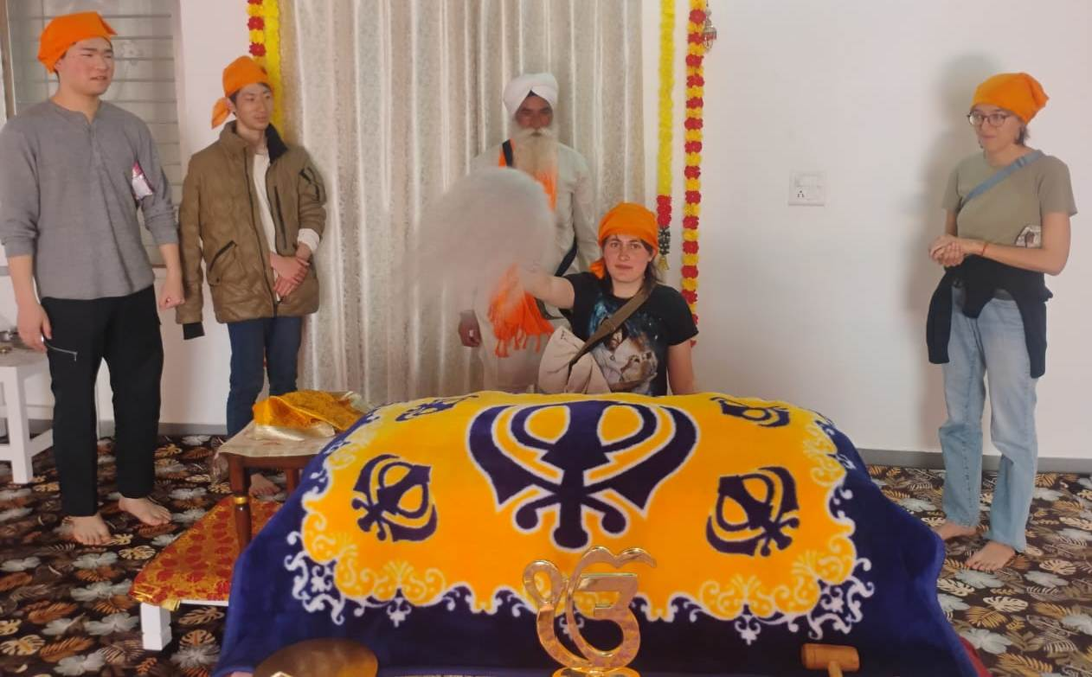

Background: Through this project we aim to provide volunteers with an enriching experience in terms of historical sites exploration, cultural immersion, eco trekking and gain grass roots experience in rural communities. Volunteers here would get chance to increase their understanding about Indian Culture, cuisine and visit places of historical importance not figuring on international tourist map.

Location &Leisure time: Volunteers would join us at our headquarters (Bandh village campus in Solan district) which is based at a rural location where they have opportunity to live & experience a typical mountain village culture and their lifestyle.

Nearby Kasauli town is a major attraction. A visit to Shimla, the state capital, will offer an opportunity to see high Himalayan Mountains and British architecture.

Work: The project will offer a mix of cultural immersion, eco trekking and understanding community life. Three activities are planned. In cultural immersion, three sites will be covered: 1: Haripur Gurudwara (an age old temple of Sikhism religion importance where people visit to take blessings and fulfill their wishes), 2: Hanuman Mandir (probably the oldest Lord Monkey Temple) and 3: Snake Temple. All these places are historical but do not figure on international tourist map.
A short eco-trek will also be planned involving a cleanliness drive.

During the camp, a community grass roots experience sharing session will also be planned where they would participate and learn from our ongoing initiatives like NFE, women empowerment, NRM (Protection of fresh water sources), organic farming etc.

Accommodation and Food: Volunteers will live in shared accommodation in both places. The minimum basic amenities will be available. Vegetarian food will be served but in the town you will have access to non-vegetarian meals as well. A cook will be there but volunteers are expected to help him and occasionally cook their own meals and self-management is required.

Requirements: Interest in understanding different life styles and issues with a sharing and learning ability, High motivation & open mindedness is a must.

International Terminal: New Delhi and Chandigarh Nearest railway station: Kalka
Participation Fee: Euro 230

RC-02/26 Bandh Peace and Resilience Peace 10 Vols. 23.02.26 – 05.03.26

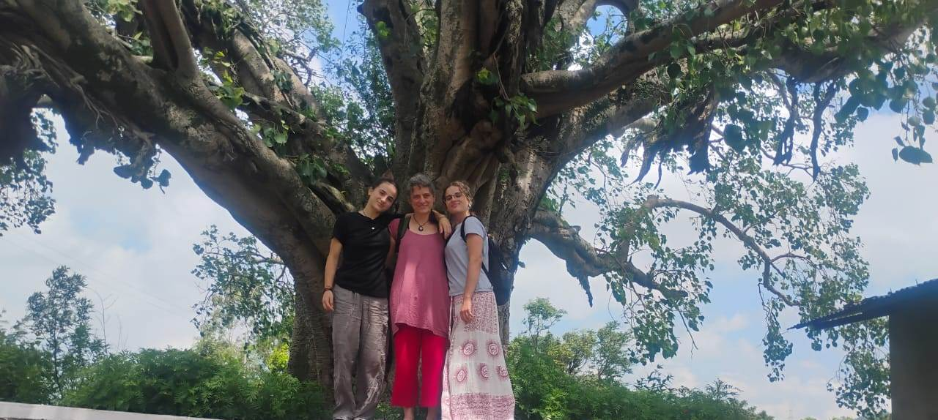
Background: The Peace and Resilience Project is set in a calm, nature-rich region of Himachal Pradesh, far from any conflict zones. It invites volunteers from around the world to engage in meaningful, creative activities that promote peace, inner strength and cultural connection. This project also aims to send a global message that India is safe and welcoming for volunteers, despite external tensions. Each activity is designed to build emotional resilience, spark reflection, and foster a deeper sense of global solidarity.

Location & Leisure time: Ruchi campus which is located near Bandh village. It is 30 km from Kalka town and 60 km from Chandigarh city. The area offers a unique opportunity to live with nature in a peaceful environment.

Self organized city tours and excursions. Old Sikh and Hindu temples in the near vicinity can be visited. Nearby Kasauli town, a hill station, is a major tourist attraction. A visit to Shimla, the state capital, will offer an opportunity to see high Himalayan Mountains and British architecture.

Work: Volunteers would compile information to convey message on peace, harmony and a safe environment having space for everyone regardless of their caste, creed and religion. They will visit 3-4 communities and interact with the people to better understand local values, culture, behaviour and prepare materials for future volunteers. The volunteers will also spend time on plantation, nurturing already planted trees, cleaning etc, do wall or pot planting with peace message promoting global peace and an environment for a better living.

Since peace and environmental education and protection is the focus of the camp they will be expected to create awareness on issues like global warming, climate change, Carbon emission, sustainable lifestyle etc. while visiting local communities.

The volunteers will also get an opportunity to get an exposure of other humanitarian projects, meeting with women groups, physical activity in RUCHI campus and work in communities or slums.

Accommodation and Food: Volunteers will live in the RUCHI campus in shared accommodation. All minimum basic amenities will be available with library facilities. Vegetarian food will be served. A cook will be there but volunteers are expected to help him and occasionally cook their own meals and self-management is required. Sleeping bags are not necessary but required for personal hygiene.

Requirements: Interest in peace keeping, harmony, environment and climate changing issues.

International Terminal: New Delhi and Chandigarh Nearest railway station: Kalka
Participation Fee: Euro 230

RC-03/26 Solan/RUCHI Holi Mela-Festival of Colors 10 Vols. 02.03.26 – 11.03.26
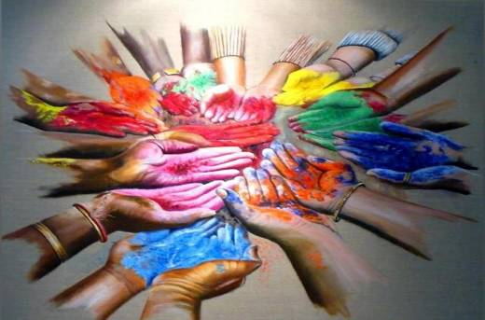

Background: One of the major festivals of India, Holi is celebrated with enthusiasm and gaiety on the full moon day in the month of Phalgun which is the month of March as per the Gregorian calendar. Holi is also called the Spring Festival - as it marks the arrival of spring the season of hope and joy. Entire country wears a festive look when it is time for Holi celebration. This year, main Holi festival (playing with colours) falls on 4thMarch, though celebrations in different forms start 4 days before the main festival. Market places get abuzz with activity as frenzied shoppers start making preparations for the festival. Heaps of various hues of colors can be seen on the roadside days before the festival. Womenfolk cook loads of sweet dishes for the family and also for the relatives.

People light a bonfire at important crossroads, called Holika on the eve of Holi festival and celebrate the victory of good over evil, known as Holika Dahan which is celebrated in the evening of 3rd March, 2026

Location & leisure: The project site is Ruchi campus and the nearby Bandh village (1 km) in Solan district. It is 30 km from Kalka and 70 km from Chandigarh. The village is small with 40 odd families.

Self organized city tours and excursions. Old Sikh and Hindu temples in the near vicinity can be visited. Nearby Kasauli town is another hill station as a tourist attraction. A visit to Shimla will offer an opportunity to see high Himalayan Mountains.

Work: The Holi festival celebrates the onset of spring and renewal. Coming forth with the full flush of life, the invigorating air of Holi festivities spreads into the lives of people throughout the year.

Being a festival camp, the major focus of this camp is on leisure and enjoy festivities. However, with an initial orientation on festivals, you will get chance to participate in our ongoing humanitarian actions like Non formal education, women empowerment initiatives, environment conservation, waste upcycling, organic farming etc and have an interaction with local communities to encourage cross cultural exchanges and provide a deeper insight of our culture. The major festival will be attended to on 14th March when you will play with colors.

Accommodation: Volunteers will stay at RUCHI campus on twin/triple sharing basis. Bed and beddings are provided. Simple basic amenities will be available; bringing personal sleeping bag is desirable. Asian squat type toilet & English WC with hot and cold showers are available. Our cook will serve authentic Indian vegetarian meals.

International Terminal: New Delhi and Chandigarh Nearest railway station: Kalka (30 kms)
Participation Fee: Euro 230/-

RC-04/26 Tibetan Culture & Social Dev. Dharamshala & Solan SOC/CUL 10 Vols. 16.03.26 – 25.03.26

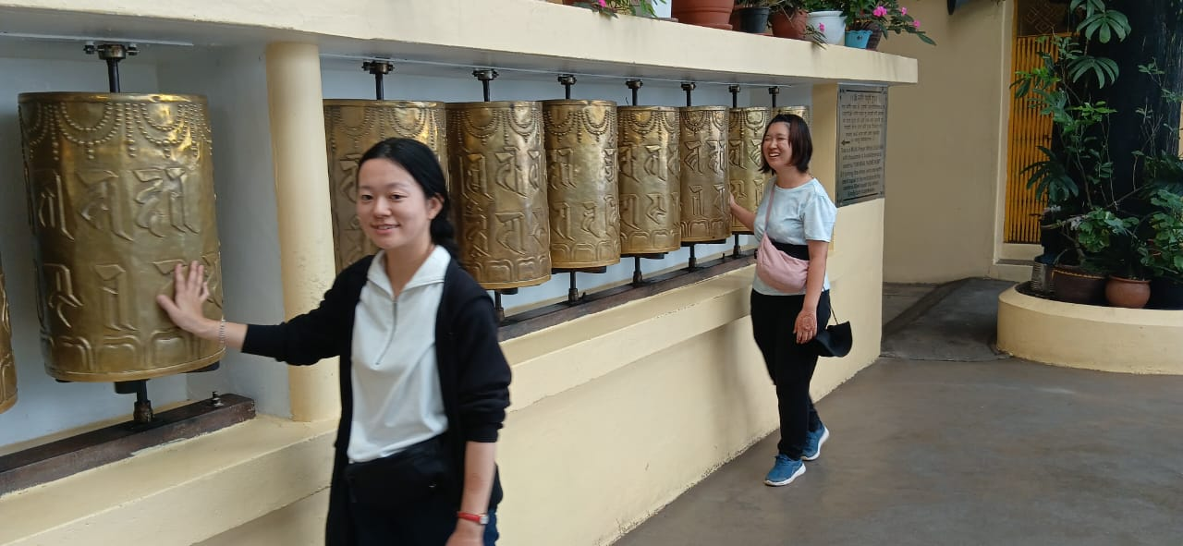

Background: Through this project we aim to provide volunteers with an enriching (rural & urban) experience where they would participate in our ongoing rural community development initiatives aimed at uplift of marginalized people and later move to McLeodganj, Dharamshala where Tibetan Government in exile has its head quarters. Volunteers here would get chance to increase their understanding about Tibetan Culture, their movement and their ongoing struggle to keep their identity alive.

Location &Leisure time: RUCHI Campus at village, Bandh of Solan district and the town of Mcloedganj in Dharamshala, a tourist hub.

The project will start from village Bandh, Solan district where headquarters of RUCHI is located and terminate in Dharamshala, the headquarters of Tibetan Government in exile. Opportunities will be there for short and long treks in the mountains. While in RUCHI campus, nearby Kasauli town is a major attraction. A visit to Shimla will offer an opportunity to see high Himalayan Mountains and British architecture. Dharamshala is well known as a much sought after tourist attraction.

Work: In the beginning, volunteers will live & work with rural communities to experience a typical mountain village culture, their lifestyle and during process join our ongoing initiatives like NFE, women empowerment, NRM (Protection of fresh water sources), organic farming etc. They will also visit place of historical and cultural importance for their personal development.

During the last three days, the volunteers would move to Mcloedganj in Dharamshala which is a touristic town and also Secretariat of Tibetan Government in exile. Over here they would visit Tibetan, monasteries, museum, schools and join language classes with Tibetan monks. There is a likelihood that we may take up some cleanliness work or some other activity. Otherwise, this week will be more of touristic with leisurely walks and culture sharing.

Accommodation and Food: Volunteers will live in shared accommodation in both places. The minimum basic amenities will be available. Vegetarian food will be served but in the town you will have access to non-vegetarian meals as well. A cook will be there but volunteers are expected to help him and occasionally cook their own meals.

Requirements: Interest in understanding different life styles and issues with a sharing and learning ability, High motivation & open mindedness is a must.

International/Domestic Terminal: New Delhi, Chandigarh and Dharamshala Nearest railway station: Kalka
Participation Fee: Euro 260

