**ANNUAL REPORT**

2015-2016

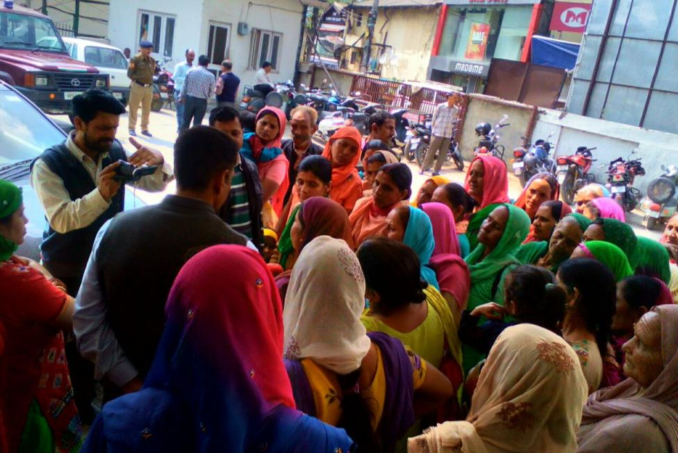

 RUCHI

Rural Centre for Human Interests

Village- Bandh, Bhaguri – 173233

District- Solan, Himachal Pradesh, INDIA

Tel: 91- 8679078500

Email: *info@ruchi.org.in*

Website: [*www.ruchi.org.in*](http://www.ruchi.org.in)

Registered as a society at village Shalana, Rajgarh 173101, Distt. Sirmour, Himachal Pradesh

Contents

1. About the Organisation

1.1. Background…………………………………………………………………………… 3

1.2. Mission Statement …………………………....................................................... 4

1.3. Vision …………………………….…………………………………………… ……. 4

1.4. Belief System 4

1.5 Strategic Objectives 4

**2. Management and Administration**

2.1. Structure 5

2.2. Finance and Accounts 5

3. Projects

3.1. Sustainable Development Goals ..………………..……….. ………………..…. 6

3.2. International Women Day…………………………….………………….……......... 6

3.3. Fight against social eveil ………….…..:…………………………………………..... 6

3.4. Legal Awareness Camp for Women ………………………………….…..………. 7

3.5. Baddi Integrated Development Water, Health and Agriculture …..……….. 7

4 . International Voluntary Service

4.1. International Volunteer Workcamps  9

4.2. Student Placements ……………………………………………………………....... 9

5. Seminars/Conference ……………………………………………………………….… 10

[5.1 Sustainable Development Goals ..………………..…………….………………..](#_Toc202241744) 10

5.2. National Action plan for Climate Change (NAPCC)…….………………….……. 10

5.3. Workshop on “Decoding corporate Social responsibility : Ideas to Action”….... 10

5.4. **I**nternational Conference n IVS Action ………………………….…..…………… 11

5.5. Global voluntary Service to Stop Climate Change along with 12 TNW ……... 11

**6. Audited statement of accounts** …………………………………………….……..... 12

From the Executive Director’s desk

I am glad to present the annual report of RUCHI for the FY 2015-16.

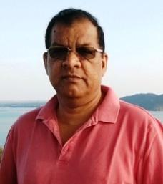

RUCHI is one of the few voluntary organizations who started working with a developmental perspective way back in early eighties. Since then a sea change has taken place in voluntary action. The voluntary sector has become professional with highly skilled manpower. Creativity and innovations have taken a lead role.

On the other hand laws governing the sector have also become more stringent. Keeping in line with modern requirements Indian voluntary organizations have adapted to be more transparent with good governance systems in place.

Working in the voluntary sector is getting more

challenging and that is what which keeps you with

full of life and distinguishes you from others.

Dharamvir Singh

Executive Director

Dated: 24 April, 2016

1. About the Organization

**1. Background**

The Rural Centre for Human Interests (popularly known as RUCHI) has incessantly worked towards uplifting the living conditions of the underprivileged section in selected regions of Himachal Pradesh, India. RUCHI through active grassroots participation and empowerment of the communities in all aspects of their development strives to minimize their dependence on external agencies. RUCHI’s focus on promoting **sustainable anthropocentric development through environmentally, socially and economically integrated activities** ensures the improvement and sustainability of rural communities and their environment.

RUCHI began as a non-profit, voluntary organization in October 1980, set up in the Himalayan foothills of the state of Himachal Pradesh. It was registered as a Society on 16 February 1983 under the Societies Registration Act, 1860.

A new Technology Resource Centre of RUCHI came up in 1994 in a small village of Bandh in Dharampur Block of Solan District which also houses the headquarters of RUCHI. This great achievement was made possible through the Council for Advancement of People’s Action and Rural Technology (CAPART), under the aegis of the Ministry of Rural Development, Government of India. RUCHI is currently working in the southeast part of Himachal Pradesh in the districts of Solan and Sirmour, in the Dharampur and Rajgarh development blocks respectively.

From the onset, RUCHI realized the importance of providing assistance and technical support to facilitate and aid the process of development by encouraging individual and community participation he process. Accepting and overcoming the various challenges is the key to RUCHI’s successful progress which today looks back on its past achievements with pride and at the one ahead with hope.

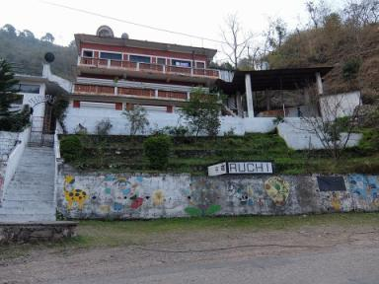

Thirty three years on, the organization is continuing with its commitment to instill an ambience of improved quality of life, a new scenario of social and economic progress and minimal dependence on others on the part of the communities. RUCHI has remained successful in achieving this only through an integrated, multi-disciplinary and participatory sustainable development.

**1.1. Mission Statement**

***RUCHI’s Mission Statement:* Integrated rural development through people-centered, environmentally sustainable action.**

With this in mind (and a view towards social and economic independence), RUCHI introduces technologies deemed appropriate to the conditions, and uses health and resource management education to socially empower and uplift rural communities.

**1.2. Vision**

**A society which is armed with information and knowledge to achieve comfortable living standards; which believe in good governance, equality and respect for each other.**

**1.3. Belief System**

* People have an inherent capacity to achieve - even in the face of adverse conditions - provided they are given with help and guidance.
* Resources, goods, information and technology should be shared amongst and between communities.
* People should be empowered to demand services by virtue of being human and as a basic human right.
* Women play an important catalytic role in development.
* Both development and management should be participatory.
* Social change can occur through economic stability and independence.
* Economic stability and independence can be achieved though optimal and *sustainable* use of local resources.

**1.4. Strategic Objectives**

1. Promote and protect the environment and natural resources, through adoption of appropriate resource management techniques, generally focused at the micro-level of watersheds.
2. Promote education and awareness as a tool to improve the plight of the underprivileged rural poor.
3. Ensure that a participatory approach is used in the conservation and promotion of natural resources.
4. Catalyze the transfer of low-cost agricultural and construction technologies which will aid in environmental protection and community development.
5. Empower women and eradicate gender inequality, namely through micro-credit and self-help groups.
6. Extend our services to the vulnerable section of elderly, and promote independence amongst this section.
7. Develop areas of mutual cooperation amongst Government agencies and NGOs.
8. Improve the community health standard, mainly through preventative measures.
9. Foster an understanding of, and focus on, integrated rural development in the young rural workforce, promoted through non-formal education.

2. Management and Administration

**2.1. Structure**

RUCHI’s daily activities are administered by an executive director. Over and above this, the management of RUCHI rests with the Governing Body, comprised of six members, each of whom is elected for a two-year term.

RUCHI lays great emphasis on ‘people’s power’. The consequence can be noticed in the environment of team spirit, collective experience, hard work and commitment in which and on the basis of which the whole organization runs. Very essentially this is manifested through the 17 full-time staff who proficiently strives to achieve the objectives mentioned above. Now, more than ever before, RUCHI has long- and short-term volunteers participating in the project activities injecting fresh ideas and knowledge into the strong RUCHI team.

**2.2. Finance and Accounts**

The details are outlined in Annexure 1 of the audited statement of accounts.

**Besides project based funding in terms of grants-in-aid, RUCHI generates income from the following sources:**

* Consultation fees.
* Infrastructure usage charges.
* Agricultural activities.
* Public contribution/donations

**At present, RUCHI is receiving funds from the following international funding bodies:**

* RNZWCS-NZAID New Zealand
* Rotary Clubs of New Zealand.
* Lionex GmbH, Germany

**RUCHI’s Indian sources of funding include:**

* Shamdasani Trust

3. Projects 2015-2016

**3.1 : Sustainable Development Goals**

About 60 people, 85% being women attended a day long seminar at RUCHI office in village Bandh on 16th February. Information on the new SDGs was passed on to the participants and some informative literature distributed.

The women shared their opinions and expressed needs to have more active access to this kind of information. Most of the women being agriculturists they also discussed various issues and concerns related to farming.

**3.2: International Women Day:**

The International Women Day was celebrated on 8th March 2016 at Bhadhoni Ghat. 74 women of various SHGs participated in the event.

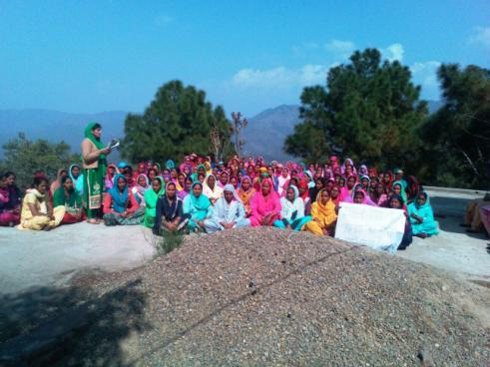

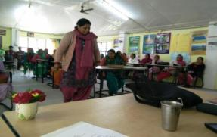

The women also used this opportunity to discuss ill effects of excessive drinking on the society and submitted a memorandum to the village panchayat against the operations of a liquor shop in village Kendol which, they felt, had spoiled the local atmosphere and attracted young children to excessive drinking.

**3.3: Fight against social evil:**

At the instance of Kendol SHG about 15 SHGs joined hands to campaign against operation of a liquor shop in the village. The women stressed that because of the liquor shop, their children have taken not only to boozing but getting addicted to liquor at the cost of their studies. They also realised that their safety was also at stake especially in the evening when people assemble there to drink. Consequently, they started raising a voice against the liquour vending in the village and when nothing happened they made a representation collectively to the office of Additional District Magistrate, Solan on 28th March 2016 against the renewal of liquor license to any vendor for next financial year. Fort three nights they guarded the area and ensured that the shope moves away from there. The campaigning gained momentum when the Kendol women got all support from other ASHGs and panchayat members during the celebration of International Women Day.

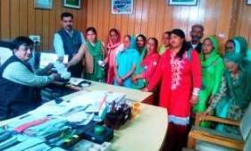

**3.4:**  **Legal Awareness Camps for women**

At the behest of women of the area, the village panchayat requested the local administration to hold legal awareness camps at Badhoni Ghat in Patta Nali panchayat on 20th March.

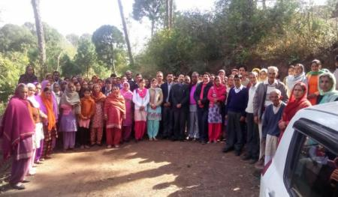

Civil Judge (Sr. Div) along with other senior advocates informed the audience on consumer rights, rights of women and how they can access legal advice, domestic violence, provisions against cheque bouncing etc. They also tipped on legal obligations in cases of processional, road blocks etc.

**3.5: Baddi Integrated Development Water, Health and Agriculture.**

First six months under this project were spent on education of people and establishing a better rapport seeking their total involvement. The strategy brought desired results. People started playing a proactive role. Various village meetings were held explaining the purpose and expectations from the project. Consequently there were agreements and disagreements on various activities involving construction works. That certainly delayed the work plan but it was worth waiting. No hassles were encountered later on. This also showed people’s involvement in decision making process.

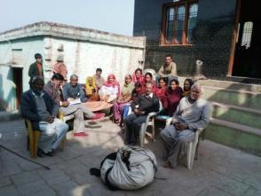

The project is planned to be executed over a period of three years and address key underlying vulnerabilities to poverty and poor health of 30 communities in both the informal settlements and neighbouring villages. High levels of poverty affect the urban slum residents and the nearby village members, the majority of whom are “scheduled caste” and live below the poverty line. Lack of access to irrigation water impacts severely on those with land who attempt to subsist in the absence of paid work. Communities, both with and without agricultural land, experience extreme hardship through lack of safe drinking water and sanitation facilities and are vulnerable to waterborne diseases. Further health priorities have been identified such as TB and diabetes which are similarly both preventable and treatable.

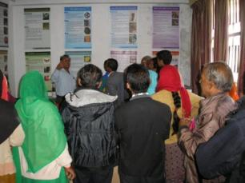

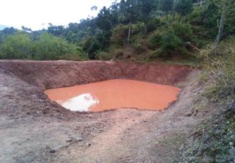

Huge earthen ponds were developed to stock rain water and allow it to seep into soil slowly thereby recharging ground water. Access to drinking water and irrigation water was also enhanced with the construction of water tanks and development and protection of natural springs. Farmers were educated on cash crops, dry land farming, water conservation etc. at Y.S. Parmar University of Horticulture and Forestry and other successful sites.

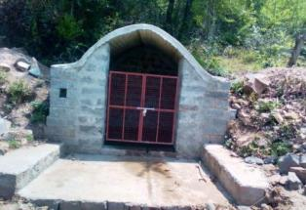

Women were organised in groups. A total of 23 SHGs were established and strengthened through information dissemination and awareness creation. Savings and thrift activities were initiated by them inculcating savings habits and supplementing their family income through small manageable income generating actions.

4. International Voluntary Services:

**4.1. International Voluntary Workcamps:**

RUCHI has been supporting both national and international students for internships as this promotes sharing available information and resources. RUCHI has already joined hands with international networks like CCIVS, NVDA and European alliance and their sub-networks. The volunteers placed through the network members help initiate inter cultural exchange, exposures/experience in community development at grass root level besides academic pursuits.

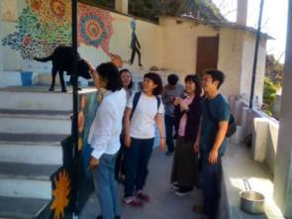

International volunteers find visiting RUCHI a learning experience. They come on study visit for a short or a long term basis to learn, exchange ideas & perspectives between RUCHI’s staff and other participants and the communities they work with. Their small donations also help the organization to cover its administrative expenses and become independent of agency funding. Depending on funds generated small projects are also taken up with this fund. 63 volunteers visited RUCHI projects in Himachal Pradesh and Rajasthan during the year 2015.

During the year, RUCHI also sent one staff to Romania during September-October 2015 to participate in an international project, Global Place, in collaboration with CAZALLA Intercultural Association of Spain as a Job Shadower.

Two other Indian volunteers were sent to participate in short term EVS project “Avatars of Nograd” hosted by Egyesek Youth Association in Hungary for a month (May-June 2015).

**4.2. Student Placements**

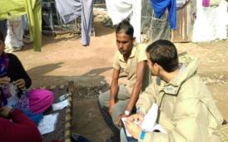

Students from various national universities doing their graduation and post-graduation in various disciplines also join RUCHI projects as interns during their university breaks. This extends opportunities to gain first hand knowledge at grass roots level and develop an insight in the practical problems of the rural communities. This broadens their horizons and develops a positive attitude for initiating more innovative humanitarian projects for communities’ sustainable development.

Like the previous years, this year too, 15 PG students of IRMA, Anand (Gujrat), visited RUCHI for two months during November-December 2015 to complete their field work segment placement. They were placed in 5 villages in groups of 3 each. This was meant for their exposure and orientation at grass roots level issues. 3 students from CU Kerala and 2 from CU Karnataka also completed their one month internship at RUCHI.

Parag Kulshreshtha, am IRMA final year student did his MTS in RUCHI for two months during 23rd November 2015 to 15th January 2016. During his placement, he completed a n annual base line study of a 3-year integrated project being executed in 30 communities in Dharampur development block.

5. Seminars/Conferences

**5.1 Technical Meeting:** Two of RUCHI staff attended the Technical Meeting of European Alliance, a European network of NGOs involved in international voluntary services, held in Tallinn (Estonia) during 1-8 March 2016**.**

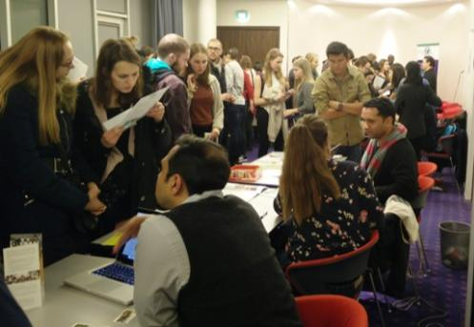

This is a very important platform of European Alliance to promote community development projects through international volunteers. More than 100 NGOs from all over the world meet during this TM.

This opportunity was also used to participate in CCIVS Day. CCIVS, based in Paris, is the largest network of NGOs promoting IVS. RUCHI is a full member of CCIVS network.

**5.2 National Action plan for Climate Change (NAPCC):** A one day workshop was organized by Youth for Action (YFA) at Secundrabad on 17 July 2015. On behalf of RUCHI, Mr. Mahip Dagar and Mr. Madan Chauhan attended this workshop where core issues like Natural Resources & Agriculture, Role of women farmers in Agriculture, Participation of local institutions, and Lack of institutional structure were discussed and views exchanged. All recommendations made were then shared with steering group of NAPCC draft committee.

**5.3 Workshop on “Decoding corporate Social responsibility : Ideas to Action”:** RUCHI Staff Mr. Madan Chauhan participated in two day work shop from 07/12 - 08/12, hosted by Youth for Action (YFA) at Hyderabad to gain awareness about parliament notification on corporate sector and CSR activities. Aiming to strengthen & build capacities of NGO representatives CSR background, policies, activities along with project development and CSR funding were shared.

**5.4 International Conference on IVS Action:** Mr. Mahip Dagar also represented RUCHI in an **International conference on IVS action for sustainability, Human Rights and Cultural Heritage** held at Paris from 5-10 October, 2015. Hosted by CCIVS this platform was used to evaluate IVS campaigns. RUCHI participated in Vision 2 Action (V2A) campaign where it organized a special project (Water for Life) in July-2015 promoting active citizenship and sustainability involving local and international youth.

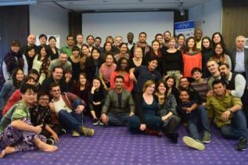

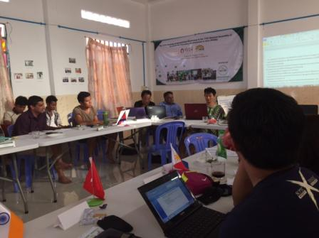**5.5 Global voluntary Service to Stop Climate Change along with 12 TNW and 11 GA of NVDA:** One of our staff also participated in the Global Volunteers meeting held 29/01/2016 – 05/02/2016 in Cambodia. One of the major aim of this meet was to develop tool to measure impact International volunteer projects are having on climate change and to develop strategies to offset that emission. As a result a six month special project is developed where a volunteer from India will visit Japan (NICE) for three months and Japanese Volunteer will visit RUCHI for another three months to work with these tools and measure our impact.

This was coincided with the TNW –cum-AGM of NVDA – the Asian network for IVS movement, where fresh elections were held and new Executive Committee was elected for coming

two year.